**Access Road Route**

Walk from station downhill (or reverse route list to end at station.) The entrance to “Parallel Path” is at the yellow stakes, halfway on Access Road; detour sometime to get the 3 VIBLAN.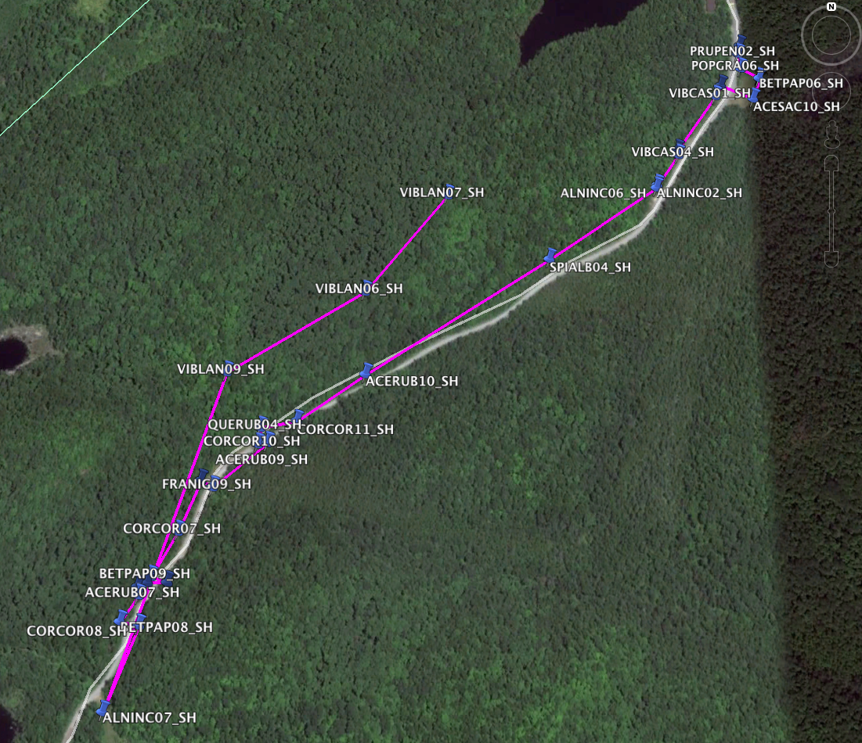

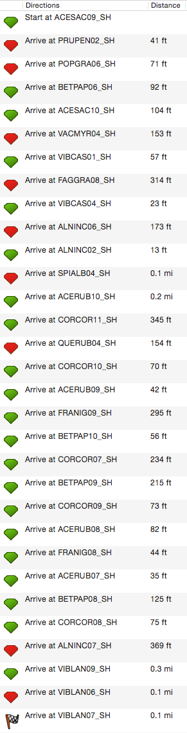

**Access Road Route**

| ID | Lat | Long | Notes | Tissue? | DBH | Hei | # |
| --- | --- | --- | --- | --- | --- | --- | --- |
| ACERUB07_SH | 45.98045703 | -74.01570302 | L of access rd before station sign | big tree with low branches |  |  |  |
| ACERUB08_SH | 45.98060204 | -74.01556699 | L of access rd before station sign, to R of franig08 | pole pruners |  |  |  |
| ACERUB09_SH | 45.98219602 | -74.01364099 | R of access rd, across from entrance to parallel path | pole pruners |  |  |  |
| ACERUB10_SH | 45.98296196 | -74.01202697 | L of access rd | pole pruners |  |  |  |
| ACESAC09_SH | 45.987168 | -74.00536504 | Access road, R-H side | 3 large trunks between 2 big erratics, good low limb |  |  |  |
| ACESAC10_SH | 45.98646602 | -74.00519103 | Access rd, open field, to L of of Acespi6 | codominant trunks, many excellent low branches |  |  |  |
| ALNINC02_SH | 45.98531996 | -74.00696799 | along paved road | fruits present (but not collected) |  |  |  |
| ALNINC06_SH | 45.98535399 | -74.00695098 | L of access red, in large mass |  |  |  |  |
| ALNINC07_SH | 45.97918499 | -74.01620401 | R of station access rd, before station sign, past huge brush pile, up cleared rd. | many stems, large mass |  |  |  |
| BETPAP06_SH | 45.986736 | -74.00506102 | Access rd, other corner of open field | medium-large tree, great healthy branches, need pole pruner |  |  |  |
| BETPAP08_SH | 45.98016601 | -74.01596102 | L of access rd before station sign, 20 ft to R of Acerub05 | pole pruners |  |  |  |
| BETPAP09_SH | 45.980667 | -74.01551804 | L of access rd before station sign, to R of acerub08 | pole pruners |  |  |  |
| BETPAP10_SH | 45.98176704 | -74.014736 | L of access rd, past station sign | pole pruners, 3 stems |  |  |  |
| CORCOR07_SH | 45.98117804 | -74.01509701 | L of station access road, just after station sign, behind Franig07 | 5-8 stems |  |  |  |
| CORCOR08_SH | 45.98012402 | -74.01567201 | R of station access rd, up cleared hill before station sign |  |  |  |  |
| CORCOR09_SH | 45.98060296 | -74.01524504 | R of station access rd, to L of Corcor 08 ~50m |  |  |  |  |
| CORCOR10_SH | 45.98218203 | -74.01380402 | R of access rd, across from entrance to parallel path, to R of Acerub09 | ~4 stems |  |  |  |
| CORCOR11_SH | 45.98243801 | -74.01315803 | R of access rd, across from faggra11 | 2 stems |  |  |  |
| FAGGRA08_SH | 45.98580301 | -74.00656901 | L of access rd, to R of vibcas04 |  |  |  |  |
| FRANIG08_SH | 45.980553 | -74.01572398 | L of access rd before station sign, to R of acerub07 | pole pruners |  |  |  |
| FRANIG09_SH | 45.981689 | -74.01454498 | R of access rd, past station sign, down ditch | pole pruners |  |  |  |
| POPGRA06_SH | 45.986865 | -74.00537401 | Access road, R-H side, just after open field | medium tree, good branches |  |  |  |
| PRUPEN02_SH | 45.98705803 | -74.00540401 | along paved road | fruits collected |  |  |  |
| QUERUB04_SH | 45.98237003 | -74.013758 | Exterior road | yellow posts |  |  |  |
| SPIALB04_SH | 45.98442201 | -74.00885903 | L of access rd in swampy area | nice big shrub, many stems |  |  |  |
| VACMYR04_SH | 45.98663902 | -74.00574096 | On bank to R of Amelae03 | One good woody stem, part of large mass |  |  |  |
| VIBCAS01_SH | 45.98650298 | -74.00585203 | along paved road | fruits present |  |  |  |
| VIBCAS04_SH | 45.98574098 | -74.00655996 | L of access rd, tucked away, spot on road bank marked by small retaining boulder | One overhanging limb & one upright limb |  |  |  |
| VIBLAN06_SH | 45.98391498 | -74.01203502 | on Parallel path (20 feet from orange marker on path) | 1 main stem & 1 young stem |  |  |  |
| VIBLAN07_SH | 45.98519197 | -74.010593 | on Parallel path, (~5 feet off path) | 1 stem |  |  |  |
| VIBLAN09_SH | 45.983012 | -74.01432697 | on Parallel path | 2 main stems, very branchy, leaning |  |  |  |

**Blue House Route**

At the bottom of the Access Road, leaving the station, turn left onto two-track road before Blue House. Park before chain.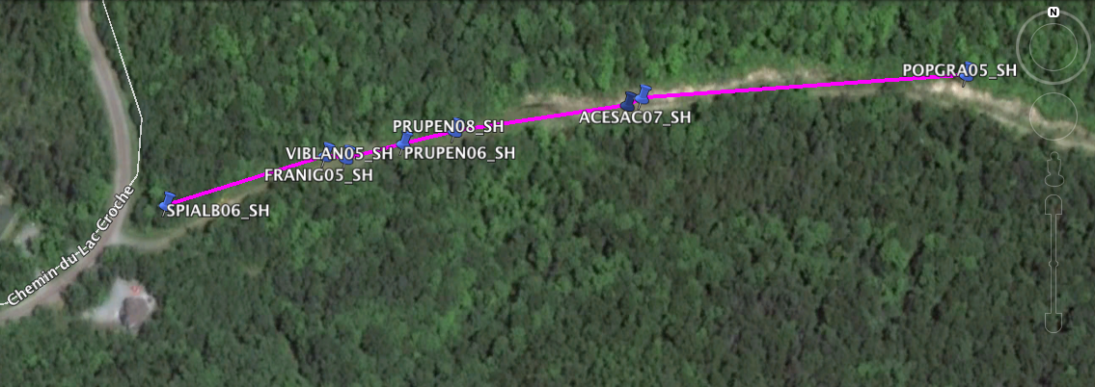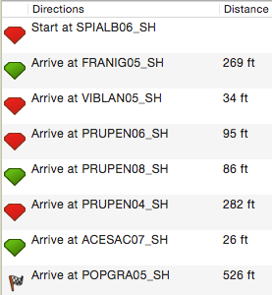

| ID | Lat | Long | Notes | Tissue? | DBH | Hei | # |
| --- | --- | --- | --- | --- | --- | --- | --- |
| ACESAC07_SH | 45.97806098 | -74.01342901 | R side of "Blue House Rd", Left of Samrac01 | lots of good branches |  |  |  |
| FRANIG05_SH | 45.97780298 | -74.01544201 | R of Blue House Rd | ~12 ft tall, gross tent caterpillars on one limb |  |  |  |
| POPGRA05_SH | 45.97816399 | -74.01136103 | L side of "Blue House Rd" | Tissue collected in rain |  |  |  |
| PRUPEN04_SH | 45.97802896 | -74.01352004 | R side of "Blue House Rd" | ID: saw old mid-branch fruit stems |  |  |  |
| PRUPEN06_SH | 45.97785604 | -74.01494597 | R of Blue House Rd, front tree of the clump | Nice big specimen. Did careful ID with book, orange lenticels, etc! |  |  |  |
| PRUPEN08_SH | 45.97791304 | -74.01461799 | R of Blue House Rd | BIG, with low branches |  |  |  |
| SPIALB06_SH | 45.97758296 | -74.01645304 | L side of Blue House Rd, directly after gate/ yellow rope. | BIG shrub! ~8 stems, tons of branches |  |  |  |
| VIBLAN05_SH | 45.977791 | -74.01531 | R of Blue House Rd, to L of Tilame03 ~15 feet, L of pointy triangular 3 foot tall rock, tagged overhead on Acespi branch |  |  |  |  |

**Campfire to Lac Cromwell Route**

Walk past Lac Croche, down “main path.” Campfire area with wood shed at clearing. Continue straight to Lac Cromwell.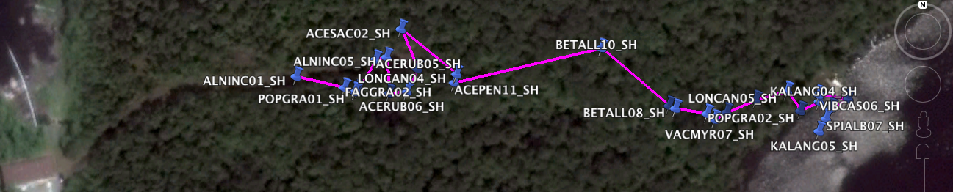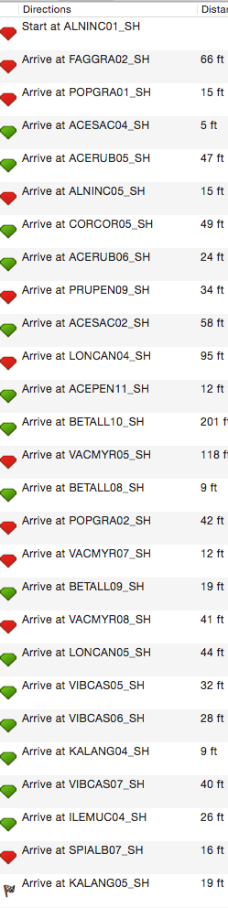

**Campfire to Lac Cromwell Route**

| ID | Lat | Long | Notes | Tissue? | DBH | Hei | # |
| --- | --- | --- | --- | --- | --- | --- | --- |
| ACEPEN11_SH | 45.98913096 | -74.00331801 | Next to Acepen10 | More stems & lower branches than Acepen10 |  |  |  |
| ACERUB05_SH | 45.98921604 | -74.00372797 |  |  |  |  |  |
| ACERUB06_SH | 45.98909802 | -74.00356502 |  |  |  |  |  |
| ACESAC02_SH | 45.98932902 | -74.00359604 |  |  |  |  |  |
| ACESAC04_SH | 45.98910498 | -74.00381899 | along main path |  |  |  |  |
| ALNINC01_SH | 45.98915401 | -74.00414203 | along main path, ~100m before campfire | waypoint="alninc1.2" in GPS, on 9/14 renamed to "alninc01" in GPS |  |  |  |
| ALNINC05_SH | 45.989225 | -74.00367097 | By campfire circle. | Many, many stems. |  |  |  |
| BETALL08_SH | 45.98903499 | -74.00216801 |  |  |  |  |  |
| BETALL09_SH | 45.98901998 | -74.00190298 |  |  |  |  |  |
| BETALL10_SH | 45.98926004 | -74.00254997 |  |  |  |  |  |
| CORCOR05_SH | 45.98908997 | -74.00365798 | By pavillion des cascades, to L of entry path |  |  |  |  |
| FAGGRA02_SH | 45.98911202 | -74.00388898 | along main path |  |  |  |  |
| ILEMUC04_SH | 45.98903599 | -74.00136 | R fork after campfire, by Lac Cromwell, on water, by rocks next to Myrgal03 | ~6stems in a mass |  |  |  |
| KALANG04_SH | 45.98908402 | -74.00142504 | R fork after campfire, by Lac Cromwell, on bank | 2 stems |  |  |  |
| KALANG05_SH | 45.98894999 | -74.00142596 | R fork after campfire, by Lac Cromwell, on bank closer to water | ~4 stems |  |  |  |
| LONCAN04_SH | 45.98916298 | -74.00330602 | R fork after campfire | ~5 trunks. ID: no milky latex. ciliate leaf edges. |  |  |  |
| LONCAN05_SH | 45.98909701 | -74.00158798 | R fork after campfire, near lake | bushy, 7-10 stems |  |  |  |
| POPGRA01_SH | 45.98909701 | -74.003835 |  |  |  |  |  |
| POPGRA02_SH | 45.98901504 | -74.00200398 |  |  |  |  |  |
| PRUPEN09_SH | 45.98918301 | -74.00351096 | across from campfire | pole pruner needed |  |  |  |
| SPIALB07_SH | 45.98899601 | -74.00138799 | R fork after campfire, by Lac Cromwell red hut | ~2 stems |  |  |  |
| VACMYR05_SH | 45.98904496 | -74.00220104 | R fork after campfire. | ~3 stems, good new growth, flagged branch above |  |  |  |
| VACMYR07_SH | 45.988994 | -74.00196601 | R fork after campfire, ~50 meters away from Vacmyr05, maybe not far enough for tissue? | 1 main stem, good branching, tall. |  |  |  |
| VACMYR08_SH | 45.98906399 | -74.00175302 | R fork after campfire, up on bank, further from vacmyr05 than vacmyr 07 was, so took tissue | 2 stems |  |  |  |
| VIBCAS05_SH | 45.98902401 | -74.00152101 | R fork after campfire, by Lac Cromwell, on bank | ~7-10 stems |  |  |  |
| VIBCAS06_SH | 45.98905896 | -74.00142303 | R fork after campfire, by Lac Cromwell, on bank, uphill from vacmyr09 | ~5 stems |  |  |  |
| VIBCAS07_SH | 45.98906902 | -74.00126997 | R fork after campfire, by Lac Cromwell, on water | tall, 4 stems |  |  |  |

**Lac Croche Loop Trail**

This is the loop trail south of Lac Croche on the station map. I believe we went left at the fork.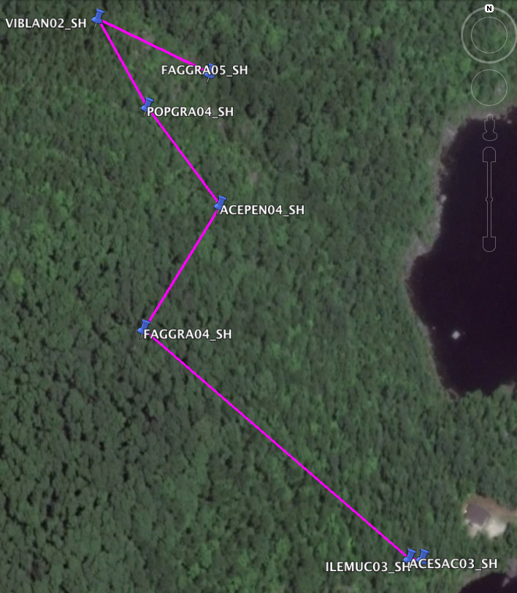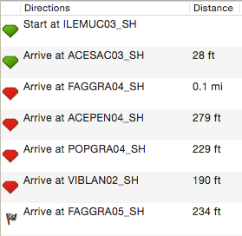

| ID | Lat | Long | Notes | Tissue? | DBH | Hei | # |
| --- | --- | --- | --- | --- | --- | --- | --- |
| ACEPEN04_SH | 45.99024198 | -74.00858402 | at Lookout #1 of Lac Croch Loop Trail | collected seeds and tissue. |  |  |  |
| ACESAC03_SH | 45.98844901 | -74.00729698 |  |  |  |  |  |
| FAGGRA04_SH | 45.98959398 | -74.00916598 | on ridgetop of Lac Croch Loop Trail | collected seeds and tissue |  |  |  |
| FAGGRA05_SH | 45.99091999 | -74.00865703 | on Lac Croch Loop Trail | tissue collected |  |  |  |
| ILEMUC03_SH | 45.98844498 | -74.007186 | along Lac Croch Loop Trail |  |  |  |  |
| POPGRA04_SH | 45.99074598 | -74.00912398 | at Lookout #3 of Lac Croch Loop Trail | tissue collected |  |  |  |
| VIBLAN02_SH | 45.99120003 | -74.00948801 | on Lac Croch Loop Trail at base of large rock | seed and tissue collected |  |  |  |

**Oak Grove Route**

North of Lac Long and East of Lac Pilon. Station can snowmobile us there across the lake? Or, we can drive: Exit station. Turn R on Chemin du Lac du Pin Rouge. After Lac du Pin Rouge (on R), Turn Right on Chemin des Hauteurs (drive NW). Turn Right on Chemin du Lac Pilon (drive NE). Continue until you round a bend at the tip of Lac Pilon that turns the road SSE. A two track road, blocked off by large rocks, forks to the left. Walk along the two-track!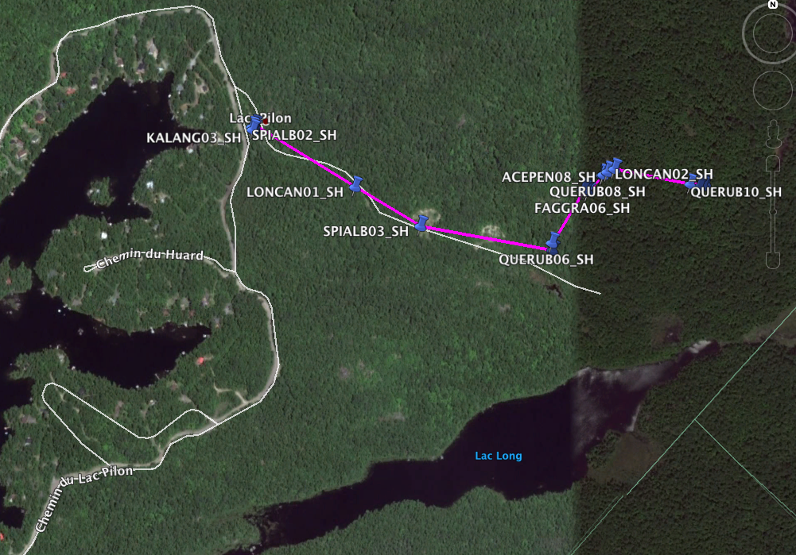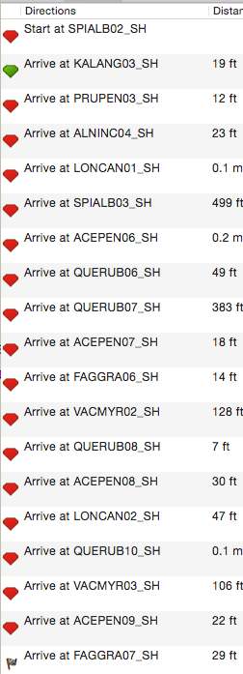

**Oak Grove Route**

| ID | Lat | Long | Notes | Tissue? | DBH | Hei | # |
| --- | --- | --- | --- | --- | --- | --- | --- |
| ACEPEN06_SH | 46.000773 | -74.00578296 | in forest NE of "oak road" (bushwhacking required)-1st stop | tissue collected |  |  |  |
| ACEPEN07_SH | 46.00180699 | -74.00497402 | in forest-2nd stop (further NE/upslope away from "oak road") |  |  |  |  |
| ACEPEN08_SH | 46.00209902 | -74.00447404 | in forest- 3rd stop (further NE/upslope than 2) |  |  |  |  |
| ACEPEN09_SH | 46.00217404 | -74.00143703 | in oak plot, a little downslope from Querub10 |  |  |  |  |
| ALNINC04_SH | 46.00307199 | -74.01343396 | along "oak road" | seed and tissue |  |  |  |
| FAGGRA06_SH | 46.00178202 | -74.00493303 | in forest- 2nd stop (further NE/upslope away from "oak road") |  |  |  |  |
| FAGGRA07_SH | 46.00215803 | -74.001547 | in oak plot, a little downslope from Querub10 |  |  |  |  |
| KALANG03_SH | 46.00299404 | -74.01348199 | along "oak road" | seeds collected |  |  |  |
| LONCAN01_SH | 46.00191697 | -74.01084797 | along "oak road" | tissue collected |  |  |  |
| LONCAN02_SH | 46.00214504 | -74.00430196 | in forest- 3rd stop (further NE/upslope than 2) |  |  |  |  |
| PRUPEN03_SH | 46.00300997 | -74.013441 | along "oak road" | seed and tissue |  |  |  |
| QUERUB06_SH | 46.00090602 | -74.00579796 | in forest- 1st stop | tissue collected |  |  |  |
| QUERUB07_SH | 46.00181504 | -74.00504401 | in forest—2nd stop (further NE/upslope away from "oak road") | tissue collected |  |  |  |
| QUERUB08_SH | 46.002053 | -74.00457303 | in forest- 3rd stop (further NE/upslope than 2) | tissue collected |  |  |  |
| QUERUB10_SH | 46.00220497 | -74.00178999 | at uphill edge of "oak plot" |  |  |  |  |
| SPIALB02_SH | 46.003044 | -74.01350403 | along "oak road" | seed and tissue collected |  |  |  |
| SPIALB03_SH | 46.001189 | -74.009185 | along "oak road", in gravel pit/"quarry" | seed and tissue collected |  |  |  |
| VACMYR02_SH | 46.00204504 | -74.00460002 | in forest NE of "oak road" (bushwhacking required)- 3rd stop (further NE/upslope than 2) | large patch, tissue collected |  |  |  |
| VACMYR03_SH | 46.00221503 | -74.00137198 | in oak plot, a little downslope from Querub10 | tissue collected |  |  |  |

**Parking Lot to Lac Croche Route**

Start at the station parking lot. Walk on the main path past the lab to the shore of Lac Croche (an area with a dam/ etc, many tags along the shore). Walk back on the other side of the lab— small path through the woods. End in clearing by weather station.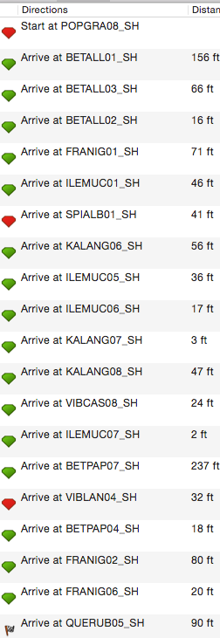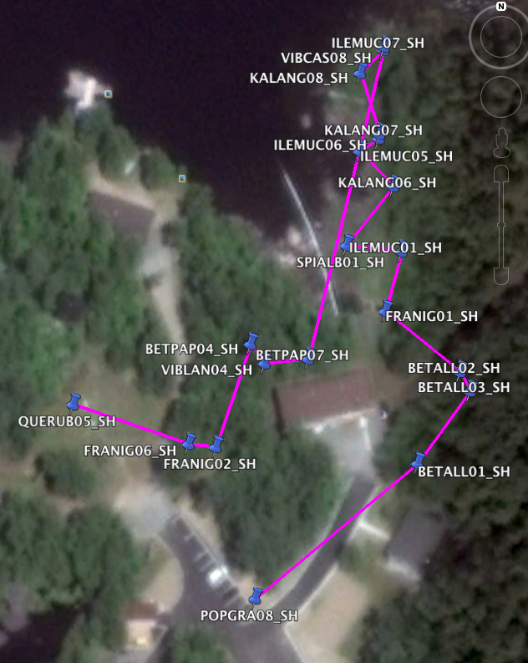

**Parking Lot to Lac Croche Route**

| ID | Lat | Long | Notes | Tissue? | DBH | Hei | # |
| --- | --- | --- | --- | --- | --- | --- | --- |
| BETALL01_SH | 45.98867096 | -74.00525699 |  |  |  |  |  |
| BETALL02_SH | 45.98885603 | -74.00513403 |  |  |  |  |  |
| BETALL03_SH | 45.98881697 | -74.00510503 |  |  |  |  |  |
| BETPAP04_SH | 45.98891202 | -74.00574298 | on small path between Lab & Pavillion Jules-Brunel. | lots of baby sorbus under this tree? |  |  |  |
| BETPAP07_SH | 45.98888202 | -74.005575 | behind lab building | loppers/ pole pruner needed. |  |  |  |
| FRANIG01_SH | 45.98897799 | -74.00535104 | along main path | (tagged 9/11, returned to GPS 9/15) |  |  |  |
| FRANIG02_SH | 45.98870398 | -74.00584398 | Roadside across from scientific instruments | Tall, will need pole pruner, but good! |  |  |  |
| FRANIG06_SH | 45.98871002 | -74.00592302 | Near "Remise" shed | TALL, pole pruner |  |  |  |
| ILEMUC01_SH | 45.98909902 | -74.00530402 | along shore of Lake Croch |  |  |  |  |
| ILEMUC05_SH | 45.98930103 | -74.00542497 | along shore, past dam on rocky shore path | 5-10 stems, short |  |  |  |
| ILEMUC06_SH | 45.98932701 | -74.00536998 | along shore, past dam on rocky shore path, further inland from ilemuc05 | very tall, ~8-10 stems |  |  |  |
| ILEMUC07_SH | 45.989512 | -74.00535498 | along shore, inland ~50 ft, past Kalang08, huge mass |  |  |  |  |
| KALANG06_SH | 45.98923003 | -74.00532799 | along shore, past dam on rocky shore path | 6-10 stems |  |  |  |
| KALANG07_SH | 45.98933598 | -74.00536797 | along shore, past dam on rocky shore path, to L of ilemuc06& a big rock | ~7stems, careful: some myrgal right next to it (same height) |  |  |  |
| KALANG08_SH | 45.98945903 | -74.00542396 | along shore, inland ~ 20 ft from Spialb 08, flagged little conifer above it | ~3 tall stems |  |  |  |
| POPGRA08_SH | 45.98839796 | -74.00572998 | corner of parking lot, across from volleyball |  |  |  |  |
| QUERUB05_SH | 45.98878998 | -74.00625897 | next to climate station | tissue collected |  |  |  |
| SPIALB01_SH | 45.98911101 | -74.00546403 | along shore of Lake Croch |  |  |  |  |
| VIBCAS08_SH | 45.98950597 | -74.00535598 | along shore,10 ft from Ilemuc07 | 2 stems |  |  |  |
| VIBLAN04_SH | 45.98887296 | -74.00570199 | on small path between Lab & Pavillion Jules-Brunel. | 3 stems |  |  |  |